Chapter 6, Solution 9.

v(t) = 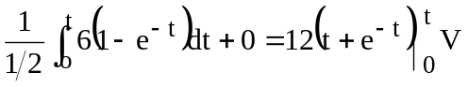 = 12(t + e^{-t}) – 12

v(2) = 12(2 + e⁻²) – 12 = 13.624 V

p = iv = [12 (t + e^{-t}) – 12]6(1-e^{-t})

p(2) = [12 (2 + e⁻²) – 12]6(1-e⁻²) = 70.66 W

